Lab Practical 03 - Identify user groups

Your group has selected a mobile app and investigate during lab practical 2. Now you are going to identify different user groups for the selected Mobile app.

1. Draw following models to get a clear understand of user groups and their needs.

# Persona(s) – 04 personas from a group

Personas are fictional characters, which you create based on your research to represent the different user types that might use your service, product, site, or brand in a similar way.

Creating personas will help you to understand your users’ needs, experiences, behavior, and goals. Creating personas can help you step out of yourself. It can help you to recognize that different people have different needs and expectations, and it can also help you to identify with the user you are designing for. Personas make the design task at hand less complex, they guide your ideation processes, and they can help you to achieve the goal of creating a good user experience for your target user group.

As opposed to designing products, services, and solutions based upon the preferences of the design team, it has become standard practice within many human centered design disciplines to collate research and personify certain trends and patterns in the data as personas. Hence, personas do not describe real people, but you compose your personas based on real data collected from multiple individuals. Personas add the human touch to what would largely remain cold facts in your research. When you create persona profiles of typical or atypical (extreme) users, it will help you to understand patterns in your research, which synthesizes the types of people you seek to design for. Personas are also known as model characters or composite characters.

Visit

|  |  |
| --- | --- |
| • | [https://www.interaction-design.org/literature/article/personas-why-and-how-youshould-use-them](https://www.interaction-design.org/literature/article/personas-why-and-how-you-should-use-them) |
| • | <https://uxpressia.com/blog/how-to-create-persona-guide-examples> |
|  | | | |

# Empathy map(s) – 04 Empathy maps from a group

As UX professionals, it is our job to advocate on behalf of the user. However, to do it, not only must we deeply understand our users, but we must also help our colleagues understand them and prioritize their needs. Empathy maps, widely used throughout agile and design communities, are a powerful, fundamental tool for accomplishing both.

Definition: An empathy map is a collaborative visualization used to articulate what we know about a particular type of user. It externalizes knowledge about users to

1) create a shared understanding of user needs, and 2) aid in decision making.

Visit:

<https://www.nngroup.com/articles/empathy-mapping/>

# User stories – 04 User stories from a group

User stories are short, simple descriptions of a feature told from the perspective of the person who desires the new capability, usually a user or customer of the system. User stories are part of an agile approach that helps shift the focus from writing about requirements to talking about them. All agile user stories include a written sentence or two and, more importantly, a series of conversations about the desired functionality.

Visit:

* <https://www.visual-paradigm.com/scrum/3c-and-invest-guide/>
* https://www.visual-paradigm.com/guide/agile-software-development/what-is-userstory/

# User flow(s) - 04 User flows from a group

There are many different pathways a user can take when interacting with a product. A user flow is a visual representation, either written out or made digitally, of the many avenues that can be taken when using an app or website. The flowchart begins with the consumer’s entry point on the product, like an onboarding screen or homepage, and ends with the final action or outcome, like purchasing a product or signing up for an account. Depicting this process allows designers to evaluate and optimize the user experience and therefore increase client conversion rates.

Visit:

• <https://careerfoundry.com/en/blog/ux-design/what-are-user-flows/>

# Service Blueprint(s) – 01 Service Blueprint from a group

Service design is the activity of planning and organizing a business’s resources (people, props, and processes) in order to

1. directly improve the employee’s experience, and
2. indirectly, the customer’s experience. Service blueprinting is the primary mapping tool used in the service design process.

A service blueprint is a diagram that visualizes the relationships between different service components — people, props (physical or digital evidence), and processes — that are directly tied to touchpoints in a specific customer journey. Think of service blueprints as a part two to customer journey maps. Like customer-journey maps, blueprints are instrumental in complex scenarios spanning many service-related offerings. Blueprinting is an ideal approach to experiences that are omnichannel, involve multiple touchpoints, or require a cross functional effort (that is, coordination of multiple departments). A service blueprint corresponds to a specific customer journey and the specific user goals associated to that journey. This journey can vary in scope. Thus, for the same service, you may have multiple blueprints if there are several different scenarios that it can accommodate. For example, with a restaurant business, you may have separate service blueprints for the tasks of ordering food for takeout versus dining in the restaurant.

Service blueprints should always align to a business goal: reducing redundancies, improving the employee experience, or converging siloed processes.

Visit:

• <https://www.nngroup.com/articles/service-blueprints-definition/>

Mobile App

1. *Create Persona(s)*

IT19134536

IT19167992

IT19136134

IT19135830

1. *Empathy map(s)*

IT19134536

IT19167992

IT19136134

IT19135830

1. *User stories*

IT19134536

* As a gamer, I want to view my data usage as a detailed report. So That I can manage my data efficiently

IT19167992

* As a Worker, I want to view Available Promotions suitable to my works. So That I can manage get suitable package to my works.

IT19136134

* As a school teacher, I want to add more data so that I can use once the allocated package data is over.

IT19135830

* As a student, I want to purchase the learning data package, so that I can view lecture recordings online.

1. *Identify user flow(s)*

IT19134536

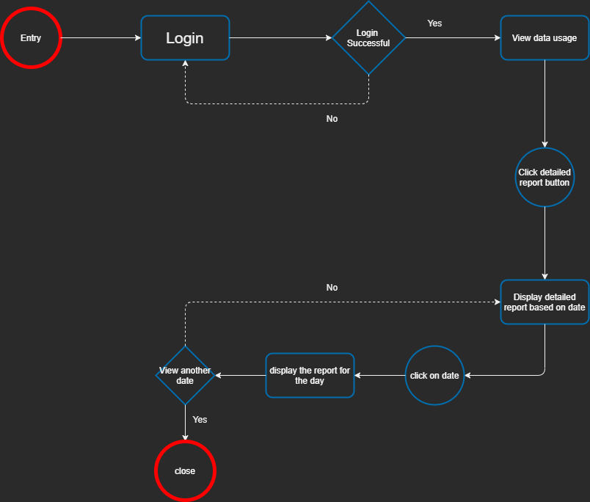

IT19167992

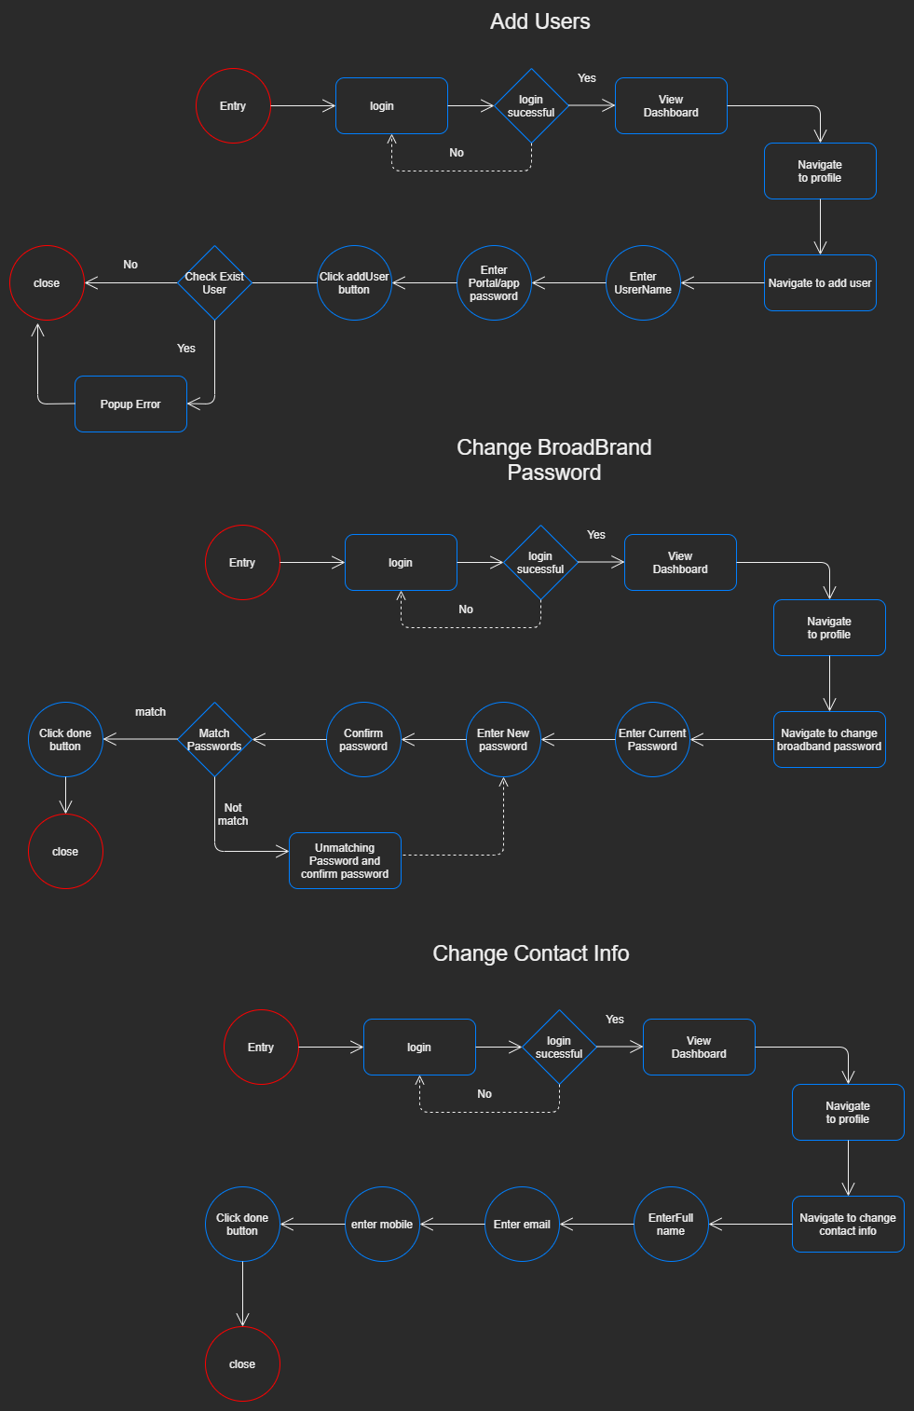

IT19136134

IT19135830

1. Diagram

   Description automatically generated*Service Blueprint(s)*